**Quadrant Chart:**

**Brief description:**

Bubble chart that is divided into four sections for plotting data that has a high volume of different results. By visually representing the data in separate quadrants, one can quickly find the distribution of data and set of items that share common traits or attributes.

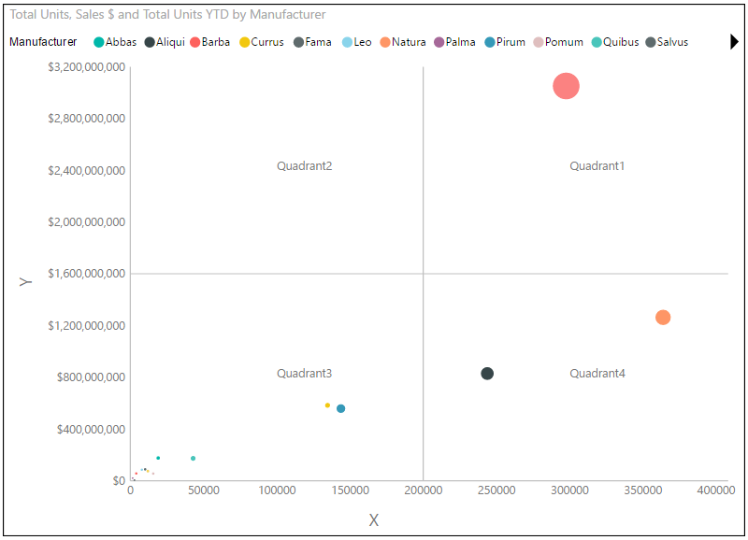

**Overview:**

Quadrant charts are bubble charts with a background that is divided into four equal sections. Quadrant charts are useful for plotting data that contains three measures using an X-axis, a Y-axis, and a bubble size that represents the value of the third measure. Below is step by step use of quad chart:

1) X-Axis field and Y-Axis field are required.

2) Adding a column in Legend Axis field will slice the X-Axis and Y-Axis measures.

3) To set radius size of bubbles, select a measure in Radial Axis field.

Below formatting options are provided for the visual:

* Set color of each bubble.
* Legends setting is available: On/off, position, title, color and text size.
* Formatting option for quadrants and quadrant lines: 1-4 Quadrant names, X-Axis division line, Y-Axis division line and Dotted/solid.
* Formatting option for X-Axis: Title, title text, labels, display units and decimal points.
* Formatting option for Y-Axis: Title, title text, labels, display units and decimal points.